**IMPERIAL COUNTY**

**BEHAVIORAL HEALTH ADVISORY BOARD**

___________________________________________________________________________

**ANNUAL REPORT**

**FY 2020-2021**

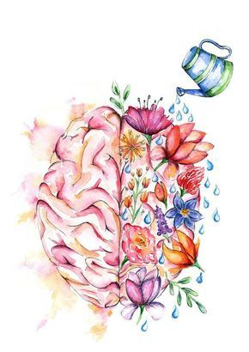

***Advocating local mental health needs while strengthening program development and operation.***

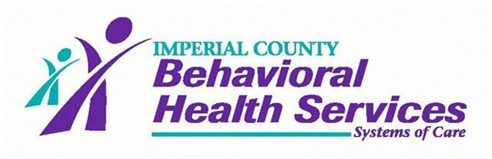

**TABLE OF CONTENTS**

**ABLE OF CONTENTS**

**Imperial County Behavioral Health Advisory Board (BHAB)**

**Members and District Map**  3

**A Foreword from the Chair** 4

**Introduction to the BHAB Annual Report FY 20/21** 6

**About our Members**  7

**Imperial County Mental Health Population** 11

**Behavioral Health Advisory Board Annual Highlights** 12

**Divisions Updates** 13

**Outreach and Collaborative Efforts**  22

**World Mental Health Awareness Month**  23

**BHAB Committee Reports**  23

**Children Services Committee** 23

**Adult & Older Adult Services Committee**  23

**California Mental Health Planning Council** 23

**(CMHPC) Data Notebook**

**Evidence-Based Treatment Practices** 24

**& Outcome Evaluation Tool Description & Updates**

**Monthly Updates** 25

**BHAB Committees** 26

**Committee Meetings Attended by BHAB Members** 27

**Legislative Mandates for FY 20/21** 28

**Behavioral Health Advisory Board Goals for FY 21/22** 30

**Recommendations to the Board of Supervisors** 30

|  |  |  |  |
| --- | --- | --- | --- |
| |  | | --- | | * **imperial county Behavioral health advisory board** | |   **Member Representation By District and Supervisor**    **District 1 – Supervisor Jesus E. Escobar District 2 – Supervisor Luis A. Plancarte**  ***Communities Represented: Communities Represented:***  ***Calexico El Centro, Heber & Ocotillo***  Hortencia Armendariz Benny Benavidez, Chair  Raul Ureña (**03/2021**) Nancy Rhodes  Carlos Acuña  **District 3 – Supervisor Michael W. Kelley District 4 – Supervisor Ryan E. Kelley**  ***Communities Represented: Communities Represented:***  **Seeley, Plaster City, El Centro, Brawley, Calipatria, Westmorland, Niland,**  **& Imperial West Side Salton City, Salton Sea Beach, Desert**  Harold Walk **Shores & Bombay Beach**  Pamela Mills-Morita Kurt Leptich, Vice Chair  Nicole Castañeda (**03/2021**)  **District 5 – Supervisor Ray Castillo Board of Supervisors Representative**  ***Communities Represented:*** Supervisor Ray Castillo  **Holtville, Winterhaven, El Centro,**  **Imperial East Side & Palo Verde**  Vacancy |  |  |

**A Foreword from the chair**

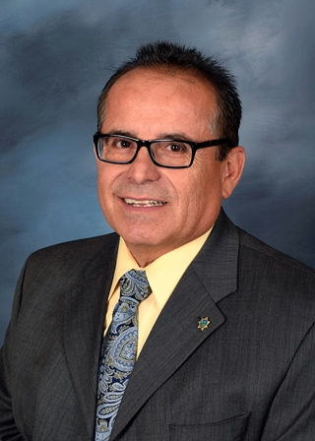On behalf of the Imperial County Behavioral Health Advisory Board (BHAB), I am pleased to present this year's annual BHAB Report to the Imperial County Board of Supervisors and the CA Association of Local Behavioral Health Boards and Commissions (CALBHBC). As members of the BHAB, we must serve as liaisons to the community to work towards providing superior services and minimizing stigma. Our goal as a board is to be responsive to community concerns including community agencies and seek to initiate processes within the department to address these concerns. We strive to incorporate quality mental health standards and access to those services in our role within the community.

To meet these standards, the board relies on its committees to allow members to familiarize themselves with programs, services, and staff of Imperial County Behavioral Health Services (ICBHS). ICBHS and the BHAB take a team approach to develop and implement problem-solving solutions to make services more compatible with the mental health needs of the community we serve. We were pleased to see the appointment of two new members and are deficient one only appointment.

The board feels fortunate to witness the expansion and to be part of a department dedicated to fulfilling the needs of the community.  As the conversation about mental health needs opens up on a national level, it has become increasingly important to stay attune to the needs of our community and to bring forth awareness to reduce the stigma associated with mental illness.  As I continue my appointment to the governing board of directors for CALBHBC, and I continue to communicate the needs of Imperial County and advocate at a statewide level in my role as President.  The increased awareness on a state and national level has delivered new and better funding sources to develop more relevant programs.  The department's outreach efforts to advocate for individuals and promote services have reduced stigma, allowing more individuals who suffer from these disorders to seek necessary treatment to live better lives.

ICBHS continues to expand services to outlying areas of the community in order to make services readily accessible to anyone who needs them.  This year was no exception with continued work towards additional sites.  Additional building re-models for Adult Services, Children Services, and Crisis and Engagement Services are also underway to design the clinics to meet the needs of client care better.

With the expansion of services, the department has increased its workforce.  This level of growth could often cause an agency to feel growing pains, but it appears the department has been able to grow with grace.  The fundamental foundation for client success is treatment based on Evidenced-Based Practices.  ICBHS treats patients using appropriate Evidenced-Based Practice models and diligently ensures that all treatment staff members are adequately trained in these areas.

One of the ongoing concerns is the 5150 project and the “Road Map” which has major limitations and inadequacies in addressing the County’s need for this particular population.  As a result, the law enforcement community elevated the issue publicly, which prompted the department to respond swiftly by initiating a Crisis Co-Response Team (CCRT).  The team has begun to address some of the inadequacies of the past practices.  This program has the potential to direct this population directly in the hands of a behavioral health professional for services and prompt timely treatment.  Like any new program, it is not without faults and glitches.  The BHAB continues to monitor the program, provide feedback to ICBHS for program refinement, and ensure their population is directed to the proper agency equipped to deal with the 5150 issues.

In the midst of COVID-19 and variants, the BHAB has witnessed a modification in the methods ICHBS services are rendered.  Clients are being handled remotely and via Tele-med, which has its limitations, as time will reveal the effectiveness but prompt response to clients’ needs must be paramount. The national experts prediction of the effects of the pandemic on mental health to the general population remain of predominate concern to the BHAB.  The foreseeability of a surge is most prevalent.

The BHAB remains concerned about the statistical reduction in services rendered or clients served.  Realizing that the pandemic affected the level of services, the BHAB is resolved to monitor and ensure that all persons in need of behavioral health services are received and not denied.  The BHAB is anxious to see an increase over pre-pandemic statistics on services rendered.

The BHAB strives to be conduit for the community, agencies and for the Board of Supervisors to ensure that local behavioral health needs are available and accessible and will remain resolved to direct and advise ICBHS of alternatives or direction.

As manifested in last year’s report, the Substance Use Disorder programs activation was greatly anticipated to address a vast number of clients in need of substance abuse treatment.  Speculation suggests that another undesirable effect of the pandemic is higher number substance abusers.  The accessibility to services for SUD is deemed an essential component to a healthy community. The BHAB will remain steadfast to ensure outreach and full utilization of the program.

On behalf of the BHAB, I would like to thank the Imperial County Board of Supervisors for their support of the Behavioral Health Department.  This department has a big vision, with huge plans and goals, and your support is what allows the department to achieve its goals.  It has been quite a journey, but I genuinely believe that as the vision comes to fruition it will have a positive impact on this county.

**introduction to the Behavioral HeALth Advisory Board Annual report for FY 20/21**

Composition of the Behavioral Health Advisory Board consists of eleven (11) members; ten (10) members who are appointed by the Board of Supervisors and one (1) member who shall be appointed by the Chair of the Board of Supervisors to represent the Board of Supervisors. Presently, one (1) vacancy exist. Recruitments and appointments are coordinated by the Imperial County Clerk of the Board's office. Public notice is provided to the public of vacant positions. Once an applicant becomes a board member, they serve for a three-year term. Upon the end of the term, if they want to be re-appointed, individuals must reapply.

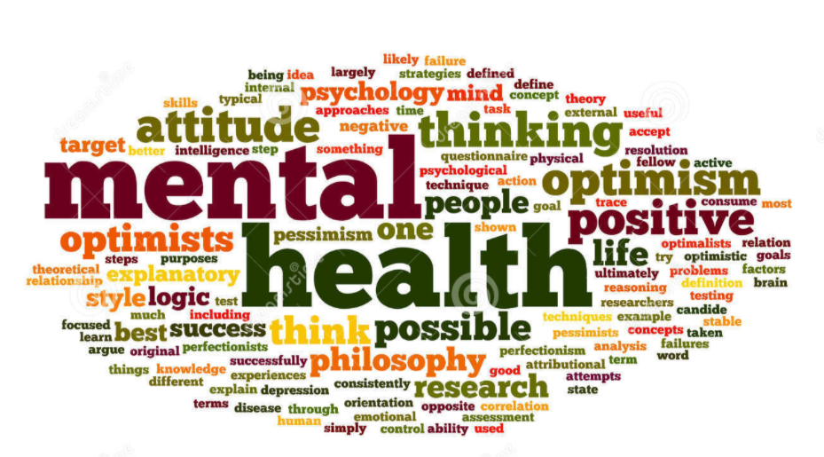

The Behavioral Health Advisory Board must comply with Welfare & Institution Code 5604(a) which requires: 1)membership reflect the ethnic diversity of the client population in the county; and 2) membership shall be consumers, parents, spouse, sibling, or adult children of consumers, who are receiving or have received mental health services.

The role and function of the board is to review and evaluate the community's mental health needs, services, and unique problems; review any county agreements entered into pursuant to Section 5650; advise the governing body and the local mental health director as to any aspect of the local mental health program; review and approve the procedures used to ensure citizen and professional involvement at all stages of the planning process; submit an annual report to the governing body on the needs and performance of the county's mental health system; review and make recommendations on applicants for the appointment of a local director of mental health services; review and comment on the county's performance outcome data and communicate its findings to the State Mental Health Commission; Perform other duties or functions as may be transferred to the Behavioral Health Advisory Board by the Board of Supervisor; assess the impact of the realignment of services from the state to the county, on services delivered to clients and on the local community.

The Behavioral Health Advisory Board of Imperial County, as a part of its state mandate, is asked to submit an annual report to the governing body on the needs and performance of the county's mental health system. We intend to produce a report that will create a shared understanding of the Behavioral Health Advisory Board's role and responsibilities, along with an overview of the work we have done and the goals we have accomplished.

**about our members**

Chair of the Board

**Benny Benavidez**

District 2 ~ Supervisor Luis A. Plancarte

Mr. Benavidez started his career at Imperial County Probation as a Juvenile Hall Officer in the 1970’s. In the 80’s, he transitioned to the services of Probation Officer and worked investigations and supervision. In the 1990’s, Mr. Benavidez transferred his knowledge to the Department of Corrections. He quickly went up the ranks and concluded his career with that agency in 2011 as the Parole Administrator. Mr. Benavidez returned to the Imperial County Probation Department as Chief PO until his retirement in November 2014. In 2015, he began his appointment to the local Behavioral Health Advisory Board.

In 2017, Mr. Benavidez was appointed to the CALBHBC Governing Board of Directors and is currently serving as the president. Mr. Benavidez possesses a degree in Criminal Justice Administration from San Diego State University and is currently a Correctional Science instructor for Imperial Valley College. He has been married for 40 years and is a father to two wonderful children, who also follow in the family tradition of public service.

Civic Involvement: Imperial County Mental Health Board (Chair); Imperial County Community Correctional Partnership (Past Chair), Juvenile Justice Committee, Juvenile Justice Joint Community Partnership, I.C. Chief of Police Association, California Chief Probation Officer Association, Regional Director for American Probation and Parole Association, San Diego Gang Commission, San Diego Prisoner Reentry Roundtable, and more.

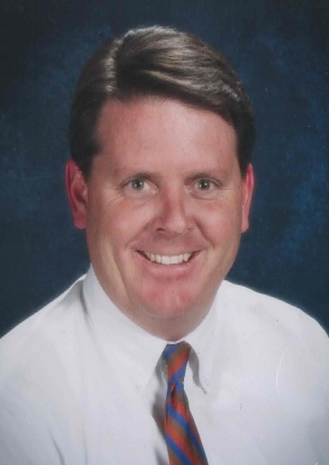Vice-Chair of the Board

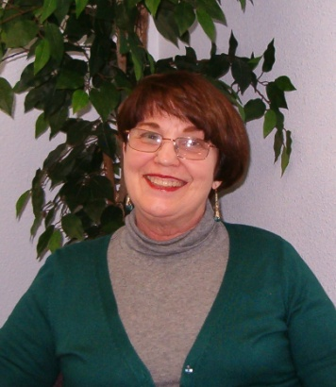**Kurt Leptich**

District 4 ~ Supervisor Ryan Kelley

Mr. Leptich is the Senior Director of the Special Education Department for the Imperial County Office of Education. He has called Imperial County home since 1965. Mr. Leptich finds great happiness with his wife of 30+ years along with their two adult daughters. Personal affiliations include the El Centro Kiwanis Club, Valley Baptist Church, and the Salvation Army. His passions include spending time with a large extended family, rebuilding antique automobiles and working around his house.

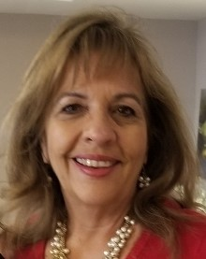**Hortencia Armendariz**

District 1 ~ Supervisor Jesus E. Escobar

Hortencia Armendariz is the mother of three sons, Cesar, Alejandro and Camilo Jr. Grandmother to Cassidy and wife of Camilo Garcia. For the last 18 years, she has coordinated the Calexico Family Resource Center and Student Services for the Calexico Unified School District. Her professional career began after obtaining a Bachelor’s Degree and a Liberal Studies Teaching Credential from San Diego State University. She began her teaching experience as a 1st grade teacher at Washington Elementary School for the El Centro School District in 1986. The following year she expanded her career opportunities by becoming a teacher for the Calexico Unified School District and then became a resource teacher. Hortencia continued her studies and obtained a Master’s Degree and administrative credential in 1995. She has served the Calexico Unified School District as an assistant principal, principal and interim assistant superintendent.

Past and present personal affiliations and memberships include Amigos de Alejandro Board Member, Calexico Education Foundation Board Member, Calexico Neighborhood House Board Member, Calexico Wellness Center Board Member, California Association of Supervisors of Child Welfare and Attendance Board Member (CASCWA) and current President for Calexico Rotary Club. Hortencia’s passion is serving her community and is always willing to help others.

**Raul Ureña**

**No Photo**

**Available**

District 1 ~ Supervisor Luis A. Plancarte

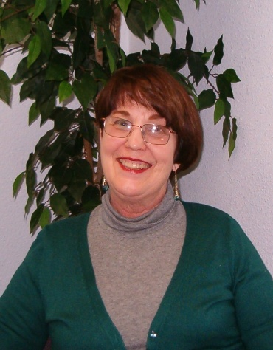**Nancy Lee Rhodes**

District 2 ~ Supervisor Luis A. Plancarte

Mrs. Rhodes relocated to the Imperial County 26 years ago with her husband and family with the sole purpose of starting the Court Appointed Special Advocates (CASA) program in Imperial County. In 1994, she started the non-profit agency CASA, as the Executive Director. CASA of Imperial County serves foster children in the dependency system. After fourteen years, Nancy retired from CASA and then within eighteen months found a rewarding volunteer job. She volunteered with the El Centro Police Department in their CIPS (Community in Police Service) volunteer program for seven years. She and her husband started a non-profit organization called BBiUganda in 2012, which supports and assists the poor in Uganda. Mrs. Rhodes has served on the Behavioral Health Advisory Board since 2000.

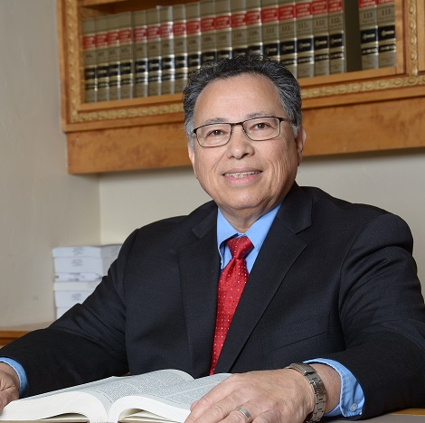**Carlos Acuña**

District 2 ~ Supervisor Luis A Plancarte

Mr. Acuña resides in El Centro. He is a valley native, born in Calexico. He is married to Rosario Acuña, a retired elementary school teacher, and they have two adult children, Christian and Karysse. He graduated from the University of Arizona, Tucson, with a degree in Secondary Education, Emphasis in English and from Western State University, College of Law, in San Diego. Today, he practices law as a criminal defense trial lawyer and has been a member of the bar since 1987. He was appointed to and served for nine years as a trustee on, the Imperial Valley College Board of Trustees representing the El Centro School District, Area 2. He also served on the Imperial Irrigation District's Local Entity that established criteria to determine which parties in and around agriculture in the Imperial County would be impacted by fallowing. He served as the Site Council parent representative for Wilson Junior High in El Centro. He worked as a deputy district attorney in the Imperial County District Attorney’s Office.

As an adjunct instructor, he taught a Criminology class at San Diego State University, Calexico campus. His hobbies include reading old school noir novels, sociology books, newspaper columns on international politics and economics on the World Wide Web, watching classic films, and spending time with his immediate and extended family and dashing out the occasional poem.

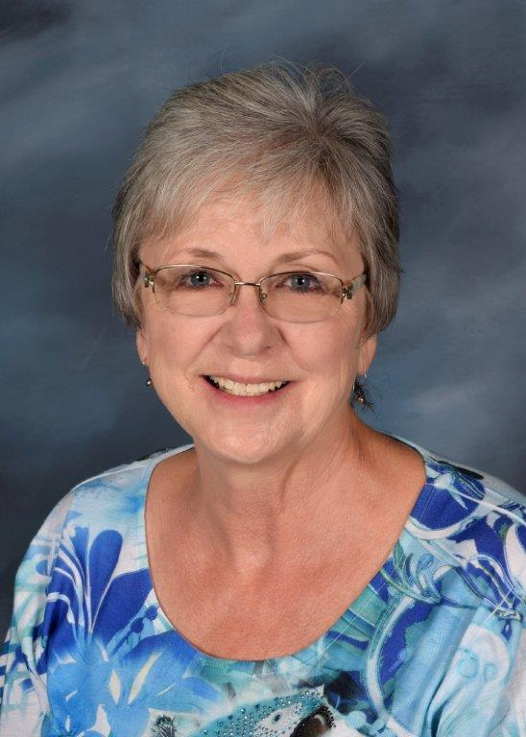**Pamela Mills-Morita**

District 3 ~ Supervisor Michael W. Kelley

Pamela Mills-Morita came to the Imperial Valley as a child when her father became stationed at the Naval Air Facility in El Centro. In 1978, she returned to the Imperial Valley upon accepting a job as a speech therapist with El Centro School District. Ms. Mills-Morita retired in July 2014 from a 35-year career as a speech pathologist.

Pamela obtained her degree from Texas Women's University and completed her graduate work in Speech Pathology at Northern Arizona University in Flagstaff, AZ. This is her eleventh year serving on the Behavioral Health Advisory Board.

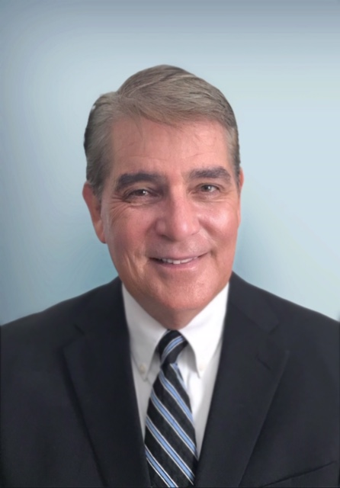**Harold Walk**

District 3 ~ Supervisor Michael W. Kelley

Mr. Walk is employed as a real estate agent by Pat Seay Real Estate. He was raised on a farm in Imperial Valley and is a graduate of Cal Poly, Pomona with a Bachelor’s Degree in Agricultural Economics. Mr. Walk has an extensive background in real estate, land management, commercial banking, finance, and business management. He has served on the Imperial County Behavioral Health Advisory Board for 20 years, and his other current community activity is membership in The Rustlers Social Club. Former activities include serving on the El Centro Planning Commission (12 years), Small Business Development Center Advisory Committee (14 years), Imperial Valley Economic Development Loan Committee (10 years), Imperial Valley College Foundation (2 years), Joint Strike Fighter Committee (2 years), Financial Institutions Fund Committee for Education (2 years) and El Centro Elementary School District Citizens Oversight Committee (4 years). Mr. Walk has two adult children, a daughter, Kelsey, with a doctorate in Physical Therapy and a son, Bryan, with a bachelor’s degree in Economics.

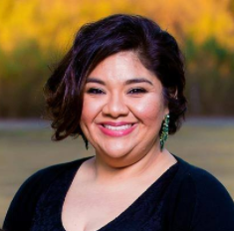**Nicole Castañeda**

District 4 ~ Supervisor Michael W. Kelley

Ms. Castañeda began her career with Pioneers Memorial Hospital in 2001. Since 2004, she has worked in the emergency room and is now the Lead Clinical Manager and Nurse Educator of the Emergency Department. She graduated from Imperial Valley College in 2003 and went on to receive her Bachelor of Science Degree in Nursing from the University of Phoenix.

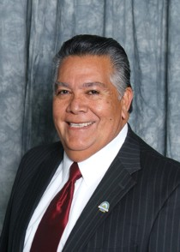**Ray Castillo, District 5 Supervisor**

Representative of the Board of Supervisors

Raymond “Ray” Castillo is a lifelong resident whose grandparents first came to the Imperial Valley in 1902. Mr. Castillo was elected to the Imperial County Board of Supervisors, District 5, in November 2010. In the 5th District, Castillo represents the communities of El Centro, Brawley, Holtville, Winterhaven and Palo Verde. Prior to Mr. Castillo’s election on to the Board of Supervisors, he had been elected to the El Centro City Council and subsequently appointed as Mayor from 2003 to 2004. Castillo graduated from CUHS in 1967, IVC in 1973 and SDSU Calexico in 1977. His law enforcement career spans back 37 years, working with the Holtville Police Department, Imperial County Probation Department, US Customs and the California Department of Corrections, where he retired in July 2004. Mr. Castillo is married to Gloria, has five grown children; Angie, Teresa, Louisa, Michelle and Raymond Jr., and fifteen grandchildren.

**IMPERIAL COUNTY MENTAL HEALTH POPULATION**

The number of individuals who suffer from Mental Illness represented in the charts below is based on the National Alliance on Mental Illness (NAMI) Mental Health by Numbers Statistical Data, which states that approximately 1 in 5 adults in the U.S. - 43.8 million or 18.5% - experiences mental illness in a given year.

The number of total Medi-Cal Beneficiaries for Imperial County is just under 50% based on the Department of Health Care Services Medi-Cal Quick Stats.

During FY 2020-2021, ICBHS served a total of 8,633 clients, representing 26% of the total population of individuals who statistically suffer from Mental Illness in Imperial County. Of the 8,633 clients served, 6,168 were Medi-Cal beneficiaries, representing 37% of the Medi-Cal beneficiaries in Imperial County who statistically suffer from mental illness.

**Total Clients Served**

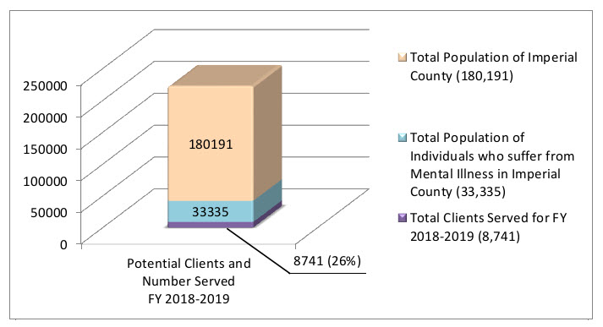

Total Clients Served for FY

2020-2021 (8,633)

8633 (26%)

FY 2020-2021

**Medi-Cal Clients Served**

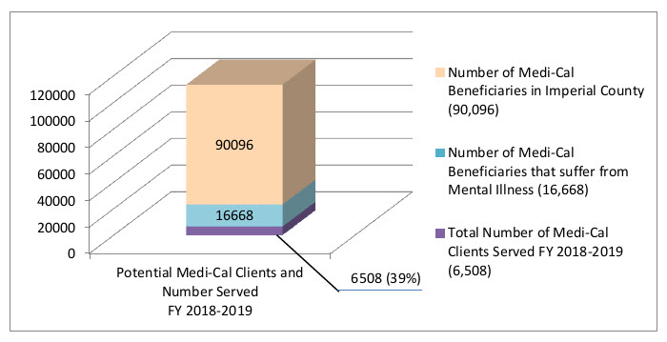

FY 2020-2021

Total Number of Medi-Cal

Clients Served FY 2020-2021

(6,168)

6168 (37%)

Pre-Pandemic Stats

|  |  |  |  |
| --- | --- | --- | --- |
| Total Clients Served | | | |
|  | FY 18-19 | FY 19-20 | FY 20-21 |
| Adults | 3,760 | 3,981 | 3,856 |
| Youth & Young Adults | 2,180 | 2,236 | 2,066 |
| Children | 3,221 | 2,985 | 2,411 |
| Mental Health Triage & Engagement Services | 1,580 | 1,342 | 1,015 |
| Total | 9,639 | 9,671 | 8,633 |

|  |  |  |  |
| --- | --- | --- | --- |
| Total Clients Served w/ Medi-Cal | | | |
|  | FY 18-19 | FY 19-20 | FY 20-21 |
| Adults | 2,168 | 2,341 | 2,308 |
| Youth & Young Adults | 1,641 | 1,693 | 1,600 |
| Children | 2,793 | 2,547 | 2,125 |
| Mental Health Triage & Engagement Services | 990 | 817 | 622 |
| Total | 6,834 | 6,802 | 6,169 |

**Behavioral HEALTH advisory BOARD ANNUAL HIGHLIGHTS**

****Behavioral Health Advisory Board members received regular updates on the department’s effort to improve access, timeliness, quality, and outcomes, in the delivery of services for those suffering from severe and persistent mental illness (refer to page 25 for an outline of updates received).

Information from these updates leads the BHAB and ICBHS to engage in a productive dialogue in which the BHAB members are able to provide meaningful, community-based insights. The BHAB members also serve on various committees (refer to page 26 for an overview of BHAB Committees). The active committees allow the BHAB to accomplish more specialized tasks, along with providing an arena to review departmental processes and report on findings. The input received from BHAB members influences the course of the department’s plans and operations.

The BHAB works closely with ICBHS staff to implement a philosophy of care and understanding. This philosophy has led to the department's transformation into a Trauma-Informed Agency and continued efforts to implement Evidence-Based Practices (EBP's). Both help fight stigma attached to mental illness (refer to page 24 for the full list of EBP's provided).

**Divisions Updates**

**Adult and Older Adult Services**

**Program Updates:**

**Providing Mental Health Services during COVID-19 Pandemic**

Services continue to be provided to clients remotely via telephone or zoom and in person when needed in order to follow the COVID 19 pandemic response that started March 2020. Those clients that presented in an emergency; required an injectable medication; or clients without the available technology were seen in person at the outpatient clinics. Mental Health Rehabilitation Technicians (MHRT) continue to provide rehabilitative and targeted case management services (food, transportation, housing, and other linkage opportunities) via telephone or on a face to face basis as needed to meet client’s needs. Staff returned to work on site starting July 1st, 2021. Staff and clients are being screened for symptoms before entering the sites. Staff are provided with PPE and cleaning supplies to clean their worksites and heavy transited areas following OSHA requirements.

**Salton City Outpatient Clinic**

ICBHS continues to work with Salton Community Services District (SCSD) in order to be able to provide services to clients living in the north end of the county. The MOU was finalized during the previous fiscal year and ICBHS is working with IT/IS to install and enable a secure and reliable internet connection to provide services to clients in the north end. ICBHS plans to certify the SCSD site to provide clients with medication support and other mental health services.

**Moral Reconation Therapy (MRT)**

ICBHS finalized the contract with Correctional Counseling Inc. to train Mental Health Rehabilitation Technicians (MHRT) from Mental Health Triage & Engagement, Youth & Young Adults, and Adult Services in Moral Reconation Therapy. The training took place August 2021 and provided training in this model to 75 MHRT’s and 20 supervising staff who will oversee the implementation of this service. MRT is a cognitive-behavioral counseling program that combines education, group and individual counseling, and structured exercises designed to foster moral development in treatment-resistant clients. As long as clients’ judgments about right and wrong are made from low levels of moral reasoning, counseling them, training them in job skills, and even punishing them will have little long-lasting impact on their behavior. They must be confronted with the consequences of their behavior and the effect that it has had on their family, friends, and community. Poor moral reasoning is common within at-risk populations.

**Dialectical Behavioral Therapy (DBT)**

ICBHS trained clinicians and Mental Health Rehabilitation Technician (MHRT) in Dialectical Behavioral Therapy (DBT). Dialectical Behavior Therapy (DBT) is a highly efficacious treatment developed for multi-diagnostic, severely disordered individuals with pervasive emotion dysregulation. DBT is also effective for patients with a variety of complex problems, including eating disorders and substance use, where emotion dyscontrol is often at the core of the patient’s problems and/or interfere with long-term maintenance of clinical progress. Clinicians will be able to treat clients presenting with these symptoms and behaviors and participate in consultation calls with the providers.

**Helping Hearts California**

A contract agreement was executed between Imperial County Behavioral Health Services and Helping Hearts California, LLC. The purpose of the contract is to extend auxiliary services to the residents of Imperial Count who are in need of social rehabilitation services. Helping Hearts provides specialized psychiatric mental health services in a long-term residential setting for adults discharged from hospitals. It will serve as a lower level of care for individuals from institutes of mental disease (IMD) and Full Service Partnership (FSP) like consumers whose traditional board and care (B&C) treatment was unsuccessful. The utilization of a long-term and transitional residential treatment facility will assist the consumers who are no longer in need of hospital-level care, but are determined to be in need of further rehabilitation prior to being reintegrated into the community. The contract with Helping Hearts will allow residents of Imperial County who meet the medical necessity criteria for FSP services to have the necessary level of treatment in a less restrictive environment, providing up to 18 months of residential treatment and rehabilitative services prior to reintegration into the community. This will assist in minimizing the risk of repeat hospitalizations, over-utilization of emergency services, and non-compliance with regular outpatient treatment services post hospitalization.

**Building Updates**

Due to growth in cases, three clinics were relocated to larger buildings for the purpose of accommodating additional clinical staffing and in order to improve access to services in the three main regions of the county. The Brawley Mental Health Services Act (MHSA) Full Service Partnership (FSP) clinic and the Adult Brawley Anxiety and Depression clinic were moved to 229 Main Street in Brawley in the north end region. The Calexico Anxiety and Depression and MHSA FSP clinic were moved to 1501 W Imperial Ave in Calexico in the southern region. The El Centro Anxiety and Depression Clinic was expanded to two programs: Team 1 and Team 2. This centrally located El Centro clinic was relocated to 313 Waterman Avenue, El Centro.

The expansion of the new sites, will improve access delivery for clients who reside in the North, South and Central areas of the county. We anticipate an increase in referrals, as the clinics will accommodate more staffing and office space to meet the needs of the local communities.

**Substance Use Disorder (SUD) Treatment Program**

**Expansion of Services:**

**Opening of the Adult and Adolescent Calexico Clinic Sites**

In order to improve access to services in the south end region, two buildings in Calexico were opened.   The expansion of the new sites improved access delivery for clients who reside in the south end area.   In addition, telehealth services are also offered and provided at these two sites.  The SUD Adult and Adolescent Calexico clinic anticipates an increase in referrals as the program will provide outreach to agencies in the south end of the county.

**Alcohol and Other Drug (AOD) Certification**

On November 15, 2020, ICBHS was certified to provide Level 1 and Level 2 Withdrawal Management (WM) at Adult El Centro SUD Outpatient Clinic. WM Level 1 and Level 2 assists clients with managing acute and post-acute withdrawal symptoms in a safe outpatient setting. SUD plans to expand its AOD certification to the other three additional clinics: Calexico Adult SUD Treatment Program and Calexico and El Centro Adolescent SUD Treatment Program.

**Youth Opioid Response (YOR) Grant 2**

ICBHS was awarded the YOR 2 grant in the amount of $500,000 focusing on Opioid Use Disorder (OUD) and Stimulant Use Disorder (StUD). The YOR 2 covers the period of March 1, 2021-August 31, 2022.  The YOR 2 will help continue to expand access for Medication Assisted Treatment (MAT) services for youth and young adults and reduce the impact of the opioid and stimulant crisis in Imperial County for youth and their families. YOR 2 will enhance and expand access to youth-relevant outreach, MAT, prevention, intervention, treatment, and recovery services. YOR 2 aims to strengthen capacity and reduce opioid and stimulant overdose related deaths and emergency department admissions through evidence based prevention, treatment, and recovery services.

**Partnership with Local Hospital**

Although El Centro Regional Medical Center (ECRMC) Bridge Grant concluded in August 2020, the hospital was motivated to continue to work collaboratively with Substance Use Disorder (SUD) Treatment Programs to continue care coordination for clients in need of SUD and Medication Assisted Treatment (MAT) services.  ICBHS assigned a SUD counselor to be located in the hospital to provide assistance and ensure patients in need of SUD and/or MAT treatment are successfully transitioned to services to the SUD Treatment programs outpatient clinics.

**Expansion of Residential Facilities**

Adult SUD Treatment Program executed a contract in February 2021 with Clare Matrix residential treatment facility, located in Los Angeles County to provide 3.2 withdrawal management, 3.1 and 3.5 residential treatment. Clare Matrix is the third contracted residential facility for SUD, which serves males and females ages 18 and older. Clare Matrix provides clients referred by SUD Treatment Programs with residential services defined as 24-hour non-medical, short-term rehabilitation services for patients with a SUD diagnosis. The quality of care and delivery of services are continually assessed to ensure key aspects of care and treatment is provided by using evidence based practices, and reliable and valid measures.

**Substance Use Disorder Telehealth Services During COVID-19 Pandemic**

The COVID-19 pandemic had a significant impact on the Adolescent Substance Use Disorder (SUD) Treatment Program.  Due to COVID-19 pandemic, school districts throughout the Imperial Valley transitioned from face to face to distance learning, interrupting on site school based SUD treatment services from mid-March 2020 through July 2021. During this period, services for both Adult and Adolescent SUD Treatment Programs were provided via telehealth platform to prevent disruption of services and provide continuity of treatment services.  Outreach efforts took place in efforts to promote the availability of SUD treatment services during the pandemic.

**Youth and Young Adult Services**

**Expansion of Services:**

**Mental Health Services to Young Adults at San Diego State University and Imperial Valley College**

Youth and Young Adults (YAYA) Services staff continue to work with San Diego state University (SDSU) and Imperial Valley College (IVC) to establish and maintain an MOU that would allow for the provision of mental health services at their campuses. YAYA has been successful in establishing an MOU with IVC, however due to the COVID-19 pandemic as well as difficulties with full-time staffing, has been unsuccessful in providing an on-site clinician. To combat this barrier, the campus will refer individuals to the Community Engagement & Supportive Services (CESS) program for linkage and outreach. At this time, an MOU with SDSU is still pending, however efforts to establish the MOU will continue. The goal is to meet the previously identified need to serve students at their college campuses due to ongoing stressors related to difficulties with the transition from high school to college, school success, financial stressors, and family-related issues via intake assessments, individual and group therapy, and linkage. Staffing would include a clinician and community service worker.

**Innovation Project: Holistic Outreach Prevention and Engagement (HOPE)**

The HOPE project will be adapting the existing mental health approach to increase access to and improve the quality of mental health services for youth and young adults aged 13-25 years. Referrals will be received from the Crisis Co-Response Team, Mental Health Triage Unit and ICBHS Outpatient clinics to provide outreach, engagement and follow-up mental health services after a psychiatric emergency. The program will focus on integrating the use of peer support specialists and using a whole-person care holistic approach to engage youth and young adults who have experienced a psychiatric emergency into treatment. Peer support specialists with lived experience will play an integral role of providing support, promoting self-advocacy and demonstrating that recovery is possible. The use of peer support specialists has been shown to be instrumental to the engagement process, reducing stigma and reducing the likelihood of relapse. Services that incorporate wellness activities to improve individual’s mental health and promote a balanced life will be utilized. The holistic interventions will be centered on wellness in the mind, body and soul in conjunction to mental health services. Clients may engage in wellness activities of their interest in the areas of mindfulness, fitness, and music/art which may consist of exercise, yoga, meditation and nutrition. Youth and Young Adults (YAYA) Services Innovation Project-HOPE- was recently approved by the Mental Health Services Oversight and Accountability Commission (MHSOAC) and will begin implementation FY21-22.

**Significant Changes:**

**Moral Reconation Therapy (MRT) Training and Implementation**

ICBHS has contracted with Correctional Counseling Inc. to provide Moral Reconation Therapy (MRT) training. MRT is a cognitive behavioral treatment approach utilized with adult and juvenile offender populations, substance use disorders, dual diagnosis and mental illness. As a cognitive behavioral approach, MRT seeks to increase the individual’s awareness on the impact of skillful decision making by enhancing appropriate behavior through the development of higher moral reasoning. MRT enhances life purpose, facilitates increased social support, and has demonstrated that MRT participants have significantly lowers levels of rearrests and reincarcerations. Mental Health Rehabilitation Technicians from Youth and Young Adults Services attended the MRT training in August 2021, where twenty-two (22) participants were certified to facilitate MRT groups with clients. MRT groups will be provided at Youth and Young Adult’s outpatient clinics.

**Program Updates:**

**Dialectical Behavioral Therapy (DBT) Training and Implementation**

During FY 2020-2021, Youth and Young Adults began implementing Dialectical Behavior Therapy (DBT) in the Outpatient Clinics. DBT is a three component evidence-based model developed for multi-diagnostic, severe, difficult-to-treat, chronically suicidal individuals. Furthermore, DBT targets and assists with reduction in suicidal behaviors, non-suicidal self-injurious behaviors, depression, anxiety, anger, eating disorders, trauma related diagnosis, substance use, and impulsiveness. In addition, DBT has been further proven to increase positive self-esteem and treatment retention. The three components in DBT include individual therapy, skills group, and phone coaching. Clinicians identified cases for DBT and began implementation and building their caseloads. Clinical staff is currently using the three components under DBT and have weekly consultation meetings to conceptualize cases, and continue with scheduled Team Meetings for further case discussion. DBT training has provided clinical staff with well-rounded skills set to address critical and adverse cognitive and behavioral issues presented by individuals who exhibit borderline personality traits, which has a typical onset of adolescence and emerging adulthood.

In November 2020, twelve (12) Clinicians and three (3) Administrators completed DBT Intensive Course Part I. In March 2021, DBT Intensive Course Part I trained Clinicians and Administrators joined twenty-six (26) Mental Health Rehabilitation Technicians to complete DBT Skills Group Training. Final training was provided in May 2021 to the same Clinicians and Administrators on DBT Intensive Course Part II.

**Children and Adolescent Services**

**Expansion of Services:**

**Children Outpatient Clinics**

As clinics regionalized, the number of children accessing mental health services increased. In an effort to meet the growing demands of the City of El Centro and outlying cities, ICBHS secured a building in June 2019 at 651 Wake Avenue in El Centro. The remodel of the El Centro clinic also known as Team 12 was completed in June 2020, and Team 12 moved into their new location on July 8, 2020. During the Covid-19 pandemic, the clinic was open to the public to meet the demands of in-person appointments when required. As of July 2021, all ICBHS staff returned to their designated clinics and programs. The El Centro Children and Adolescent Outpatient Clinic, Team 12 continues providing in-person services to high-risk clients as well as those requesting in-person appointments. Children Services continues its efforts to provide services in regional areas to improve access to mental health services.

ICBHS has been working with the Calipatria Unified School District to construct a family resource center that will provide mental health services to children, and youth and adolescents in that area. ICBHS is currently working on a ten-year lease agreement with Calipatria Unified School District. On August 4, 2020, ICBHS established a Memorandum of Understanding (MOU) with the Salton Community Services District to establish a remote clinic in the area to provide mental health services. ICBHS continues to collaborate with members of the Salton Community Services District in an effort to complete the project.

**Program Updates:**

**Dialectical Behavioral Therapy (DBT)**

ICBHS developed a contract with the Portland Dialectical Behavioral Therapy (DBT) Institute to provide ICBHS staff with a comprehensive training on the implementation of DBT. DBT is an evidenced based psychotherapy model that uses behavioral strategies to identify and change negative thinking patterns and pushes for positive behavioral changes. The model teaches clients to cope with and change unhealthy behaviors. DBT can be useful in treating clients with mood disorders, eating disorders, suicidal ideation, self-harm, and substance abuse. All clinical staff trained in DBT were required to attend two intensive five-day trainings. The initial five-day intensive training was virtually held from November 3, 2020 to November 11, 2020, and a total of 64 staff from the various ICBHS divisions were trained. The 64 trained staff consisted of Clinicians, Substance Use Disorder Counselors, Program Supervisors, Supervising Therapists, Deputy Directors, and Managers. The second five-day intensive training was virtually held from May 11, 2021 to May 18, 2021, and the same staff who attended the initial five-day training were trained. A DBT skills training was held from March 23, 2021 to March 24, 2021, and a total of 152 staff were trained, which included Clinicians, Substance Use Disorder Counselors, Mental Health Rehabilitation Technicians, Mental Health Workers, Program Supervisors, Supervising Therapist, and Managers. ICBHS is currently implementing this model in all clinical divisions.

**Providing Mental Health Services during the COVID-19 Pandemic**

The COVID-19 pandemic caused major disruptions in the daily lives of the residents of Imperial County. Throughout the pandemic, ICBHS maintained continuity of care by adopting,

modifying, and transitioning to telehealth services. As a result, all clinical staff continued to provide essential mental health services to the children and families of Imperial County. Throughout the month of June 2021, ICBHS began to transition a percentage of their staff back to their assigned clinics and programs. As of July 1, 2021, all ICBHS staff transitioned back to their assigned clinics and programs. Clinical staff are providing both telehealth and in-person services at the outpatient clinics. In-person services are provided to high-risk clients and those requesting in-person services. Children Services staff collaborated with school districts throughout the county and organized virtual presentations on mental health services for parents, school staff, and school administrators.

**Vista Sands Socialization Programs (VSSP)**

The Vista Sands Socialization Program (VSSP) is designed to assist elementary school children between the ages of 7 and 12 whose capacity to function in their home, school, and community has been impaired by emotional, behavioral problems and mental disorder(s). The primary goal of the Vista Sands Socialization Program is to:

* Maximize the child’s effective functioning in the home, school, and community while minimizing public sector costs.
* Provide a comprehensive mental health system for children at risk for out-of-home placement or out-of-county placement while providing direct services in the least restrictive environment.

Referrals to the program come from parents, school staff or by ICBH staff. The program’s success hinges on structure, positive reinforcement of desired behaviors and peer-to-peer learning. A strong working alliance is built between the family, school and Vista Sands staff. Children admitted into the program attend their regular elementary school class in the morning and attend the Vista Sands program in the afternoon from 1:00 p.m. to 4:00 p.m. During the summer session, children attend program from 8:30 a.m. to 11:30 a.m. and they do not attend school. During the regular school year, transportation of children to the Vista Sands Program and to their homes after program is provided by the school district. During the summer program transportation is provided by ICBHS.

When schools closed classrooms and shifted to virtual, or distance learning, in March 2020, the VSSP staff began integrating in-person activities into a virtual setting. The online Vista Sands Program began July 1, 2020, for the summer session. VSSP staff met the challenge of the COVID-19 Pandemic by finding ways to meet the needs of the children they serve at the program’s three school sites in Brawley, Calexico and El Centro. Virtual sessions added challenging components, making modifications to regular classroom activities and doing virtual “outings”. To help keep children engaged virtually, VSSP staff provided them with “Happy Mail” which included small toys and/or snacks. VSSP staff incorporated behavioral modification in the virtual setting and added incentives that went into the “Happy Mail”. The “Happy Mail” was delivered to the children’s homes by ICBHS staff.

For FY 2020/2021, 62 children were provided services through the Vista Sands Socialization program. As of June 30th, 2021, 52 children have received services. Of 26 children who were discharged, 18 (70%) successfully completed the program and improved their functioning in the home, school and community, 7 (27%) did not complete the program due to parent request or client having moved out of County. Only 1 (3%) client was discharged before the completion of the program due to requiring a higher level of treatment. It is expected that the VSSP will return to in person services once schools reopen for the new 2021/2022 school year.

**Assembly Bill (AB) 2083**

Assembly Bill (AB) 2083 recognizes the importance of collaboration between child serving agencies to maximize the impact of services and resources to support the safety and wellbeing of foster children, youth and families who are receiving services from multiple public programs. In order to break down silos and provide coordinated, timely, and trauma-informed services, ICBHS, Imperial County Department of Social Services (ICDSS), Imperial County Department of Probation (ICDP), Imperial County Office of Education (ICOE), and San Diego Regional Center (SDRC), developed a Memorandum Of Understanding (MOU) that outlined the roles and responsibilities of each entity to timely meet the needs of these children and youth. The MOU was approved by the Imperial County Board of Supervisors on May 25, 2021.

**Family Urgent Response System (FURS)**

FURS is a coordinated statewide and collaborative county-level system designed to provide timely mobile and in-person response during situations of instability to foster children and youth. The purpose of FURS is to preserve the relationship of the caregiver and foster child and youth, while ensuring that placement is maintained. ICBHS, ICDSS, and ICDP agreed to use the funding granted for FURS to establish a contract with Fred Finch Youth and Family Services to provide FURS services in Imperial County. The contract was approved by the Board of Supervisors on August 10, 2021.

**Mental Health Services Act (MHSA) Innovation Project**

**Positive Engagement Team (PET)**

The MHSA Innovation Project: Positive Engagement Team (PET) is an innovative strategy being implemented by ICBHS to reduce stigma related to mental illness and to increase access to services to unserved and underserved populations from all age groups through the use of trained dogs in the outpatient clinics and at outreach events. It is the goal that by integrating dogs at the outpatient clinics, clients will feel more comfortable and engaged in their treatment and improve attendance to outpatient appointments. During outreach events, the dogs will be utilized as a tool to reduce the stigma and discrimination related to mental illness.

ICBHS contracted with the Humane Society of Imperial County (HSIC) to provide training for handlers and animals; health care, grooming, feeding and cleaning of animals; and provide proper transportation for the daily delivery of animals to designated clinics or locations where services and outreach activities will be provided. ICBHS also contracted with Todd Sosna, Ph.D. Management Consulting (TSMC) to evaluate and analyze the PET project. With the assistance of TSMC, surveys were developed to be provided to clients while waiting for their scheduled appointments and to the general community during outreach events. However, on March 2020, all in person services at all of ICBHS outpatient clinics and outreach events stopped due to the COVID-19 pandemic and California stay at home order. Additionally, none of the dogs were allowed at the clinics, as all routine non-urgent appointments were conducted via telehealth or phone.

Due to the obstacles and challenges posed by the COVID-19 pandemic, The PET project had to adjust to the “new normal”. During fiscal year (FY) 20/21, the HSIC trained two new dogs, Betty Boop and Stevie to continue providing services during the pandemic. The PET project staged no-contact outreach events. For example, ICBHS provided mental health education by a mental health professional via Facebook, one of the new dogs, Betty Boop, also made an appearance during the Facebook presentation. During FY 20/21, the PET Project participated in twenty (20) outreach events, reaching about 313 people; however only eleven (11) outreach surveys were completed, nine (9) were in English and two (2) were in Spanish. At the Children’s Outpatient programs, when an intake assessment was scheduled via Zoom, Betty made her entrance on the screen before the appointment, helping the children and their parents/caregivers become more comfortable before they met with the clinician. During FY 20/21, sixteen (16) engagement surveys were completed, seven (7) were in English and nine (9) were Spanish.

As restrictions in Imperial County were lifted, Betty and Stevie, started making weekly appearances at the Imperial Valley Mall, where ICBHS staffs a resource table. Betty also interacted with children housed at the Betty Jo McNeece Receiving Home. While at the receiving home, ICBHS staff and Betty assisted in helping the children feel at ease about receiving services and letting them know that one of the dogs would be at the clinics to make them feel comfortable as in person services resumed. The dogs have also started to slowly make their presence known at the outpatient clinics where in-person services have slowly resumed.

**First Step to Success (FSS) and Trauma Focused Cognitive Behavioral Therapy (TF-CBT)**

The FSS program provides early mental health prevention and early intervention services to unserved and underserved children ages 4 to 6 in Imperial County. Services are provided in the child’s classroom and in their home.

The TFCBT program is a psychotherapy prevention and early intervention designed to help children and youth ages 4 to 18 who have been exposed to a traumatic event in their lives. All services are also provided in the child/youth’s school, home or out in the community.

On March 2020, all schools in Imperial County closed due to the COVID-19 crisis. During FY 20/21, Imperial County was severely impacted by the COVID-19 pandemic. ICBHS immediately mobilized by utilizing the County’s telecommuting policy so mental health rehabilitation technicians (MHRTs) and clinicians could continue, with minimal interruption, in providing mental health services to their clients and their parents/legal guardians from their homes. MHRTs and clinicians utilized several platforms such as telephone calls or video conferencing: Zoom. As restrictions lift, ICBHS will be transitioning to in-person services. It is expected that once schools reopen FSS and TFCBT staff will resume providing prevention and early mental health intervention services to young children in their classrooms, homes and out in the community.

**Mental Health Triage Unit and Engagement Services**

**Expansion of Services:**

**Crisis Co-Response Team**

Imperial County Behavioral Health Services (ICBHS) in collaboration with Law Enforcement Agencies (LEA) in Imperial County have joined forces to provide services in response to 911 calls to individuals experiencing psychiatric or emotional crisis. This Crisis Co-Response Team (CCRT) consist of law enforcement officers and behavioral health staff working together with the goal to prevent unnecessary placement of individuals on involuntary holds and to avoid the use of acute involuntary psychiatric hospitalization, when appropriate, by providing alternative treatment services. The ICBHS-CCRT provides on-site services in the community, which may include safety assessment, crisis interventions, brief counseling, family collaboration, and linkage and referral to community resources including other outpatient mental health, substance use and medical services, as appropriate. Additionally, the CCRT model will provide on-going efforts in effectively delivering a crisis continuum of care that results in the reduction of harm, arrests, and use of jails and emergency departments and that promotes the development of and access to quality mental and substance use disorder treatment and services. Due to the success of this program, and the need of additional services, the CCRT expanded their hours and days of operations to Monday through Sunday from 8:00a.m. to 10:00p.m.

**Significant Changes:**

**Helping Hearts**

The Mental Health Triage and Engagement Services (MHT&ES) established a contract with Helping Hearts California, Inc. Helping Hearts is an Adult Residential Facility that is certified to provide social rehabilitation services. This facility serves consumers with a serious behavioral health condition who no longer meet medical necessity for an acute psychiatric hospital or who have reached treatment goals in a locked psychiatric adult residential facility. However, this adult consumer needs further treatment services such as individual and group therapy, case management, and assistance with accessing needed medical and psychiatric appointments, as well as community-based activities and other support services that will teach and enhance skills for independent living including proper medication regime, social skills, financial management/budgeting and family reconciliation. This includes consumers learning to adjust to their behavioral health symptoms and medical conditions; consumers previously unsuccessfully discharged to family due to shortage of placement options; and/or consumers who have utilized psychiatric hospital units as their primary provider for behavioral health issues. The contract became effective February 2021 that includes 12 dedicated beds available to Imperial County Residents.

**Center for Evidence-Based Practices at Case Western Reserve University**

The Mental Health Triage and Engagement Services has established a Memorandum of Understanding with the Center for Evidence-Based Practices at Case Western Reserve University. Case Western Reserve University will provide professional consultants and trainers to conduct consultation, evaluation, and training services. The clinical training will focus on Assertive Community Treatment (ACT) Standard Training Modules, Foundations of Motivation and Engagement, Stage-Wise Treatment, and understanding addictions/DD Model. The overall goal is to increase continued education for ICBHS Mental Health Providers by enhancing therapy education in helping individuals become more self-reliant; therefore, improving their quality of life, relationships, and assisting with them becoming independent.

**Program Updates:**

**Mental Health Triage Unit and Engagement Services (MHT&ES)**

The MHT&ES continues to focus on improving mental health service delivery along with community agencies as we continue to navigate the challenges with the current COVID 19 pandemic. Despite these challenges, many of the changes implemented during the pandemic have offered a spectrum of options for remote and in-person care. In addition, it has promoted greater integration of behavioral and physical healthcare, taking safety measures for prevention of viral exposure, increased collaborative decision-making, and modifying safety plans that include new technologies and broader support systems of digital health interventions. Efforts will continued to be made in attempting to reach all populations and integrating new approaches that are responsive to clients and ensuring that mental health services are immediately available to individuals experiencing mental health crisis. Furthermore, despite the change in the process of providing services, MHTUES continues with the unchanged objective to provide the same standard and quality of care whether the client is seen-in-person, by telephone, or through telehealth. During FY 2020–2021, the MHTU underwent the following significant changes and expansions:

**Community Engagement Supportive Services (CESS)**

The CESS program continues to provide outreach and engagement services to individuals 14 years of age and older including those who are homeless or at risk of homelessness. Referrals are initiated by the community, County Jail, Mental Health Court, Woman Haven, Projects for Assistance in Transition from Homelessness (PATH), and Psychosis Identification and Early Referral (PIER) Program. During FY 2020-2021, CESS faced the impact of the current COVID-19 Pandemic. This challenge resulted in limiting the resources and avenues to provide educational information and conduct outreach and engagement services in person. Therefore, the CESS program started to utilized telehealth services and implement virtual models to better serve the community and ensure clients were receiving needed services. In addition, PIER groups were conducted via zoom. The PIER Program also conducted home visits when additional support was needed. During home visits, necessary precautions were taken. In efforts to continue to expediting delivery of services, the CESS Program re-strategized the necessary tools to facilitate community engagement activities remotely in order to improve Outreach and Engagement services within the community during the current pandemic.

**Jackson House Crisis Residential Treatment Facility**

Imperial County continues to collaborate with the Jackson House Crisis Residential Treatment Facility. The Jackson House was a much-needed voluntary short-term Crisis Residential non-medical facility program that provides therapeutic and rehabilitation services in a residential treatment facility.   Currently, ICBHS has a Memorandum of Understanding (MOU) with BH-IC Opco, LLC (dba) Jackson House that includes 10 dedicated beds for ICBHS clients 18 years and older who meet medical necessity criteria, admission criteria and are experiencing an acute psychiatric episode or intense emotional distress and require crisis stabilization and medication monitoring. Even though ICBHS contracted for 10 dedicated beds when necessary additional beds can be occupied to ensure services are provided to individuals experiencing an acute psychiatric episode or intense emotional distress. Beginning January 2020, MHTU began utilizing the services offered by the Jackson House Crisis Residential Treatment Facility. Despite the pandemic, and the facility requiring a negative Covid-19 test as criteria for admission, the usage and admission into the Jackson House, facility has remained consistent.  In FY 19-20, we had 83 admissions and in FY 20-21, we had 134. The average beds occupied per day was 10 beds.

**Outreach and Collaborative Efforts**

****The Behavioral Health Advisory Board has continually encouraged the department to improve collaborative efforts and relationships with outside agencies, including local law enforcement agencies, hospitals, school districts, County Jail, and Probation staff as reflected below:

* Protocols between local emergency departments and ICBHS were drafted to enhance the working relationship and continuum of care when treating 5150 individuals in the community.
* Mental Health Triage Unit and Engagement Services (MHTUES) has now collaborated with local law enforcement to reach out and identify homeless individuals who would benefit from mental health/substance use treatment and other supportive services including, but not limited to emergency shelters.
* MHTUES has contracted services with Women Haven Emergency Shelter as a result of the growing concerns with the homeless population in Imperial County. This expansion of services has assisted ICBHS with providing needed emergency housing services to homeless women and children.
* Quarterly meetings between ICBHS, emergency departments, and law enforcement were held to review progress in collaborative efforts and problem solving obstacles.

As an additional effort, ICBHS staff focused on outreach efforts to the community to educate and reduce the stigma attached to mental illness. ICBHS offered multiple trainings to staff and outside agencies to bring awareness to the community and to provide tools to agencies to assist with providing quality care to mental health clients throughout the community. These trainings allowed outside agencies to acquire a better understanding of how to work with individuals suffering from Mental Illness and facilitated in establishing awareness of the services ICBHS offers and the role the department plays in the community.

Additional outreach efforts include the weekly wellness radio show in both English and Spanish. The radio show is broadcast on KXO and available on-demand and by podcast. The ICBHS website, <http://www.co.imperial.ca.us/behavioralhealth/index.asp> continues to provide user-friendly access to information regarding services offered by Behavioral Health Services.

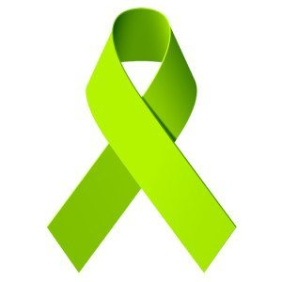**World Mental Health Awareness Month**

ICBHS had a drive-thru event held on May 26, 2021, at the Imperial County Behavioral Health Services located at 202 N. 8th Street, El Centro. Center for Clinical Training (CCT), Positive Engagement Team (PET) and the Substance Use Disorder (SUD) Programs distributed brochures on their services and disseminated goodie bags with incentives.

**Behavioral Health Advisory Board COMMITTEE REPORTS**

**Children Services Committee**

The committee met on June 14, 2021, to conduct a site visit of the department’s Children Service Programs. Sub-committee members in attendance were Kurt Leptich, Nancy Rhodes and Hortencia Armendariz.

**Adult and Older Adult Services Committee**

The committee met on June 14, 2021, to conduct a site visit of the department’s Adult and Older Adult Service Programs. Sub-committee members in attendance were Pamela Mills-Morita and Harold Walk.

**California Mental Health Planning Council Data Notebook**

The Behavioral Health Advisory Board completed the California Mental Health Planning Council’s (CMHPC) 2020 Data Notebook questionnaire regarding data from the external quality review organizations. The Data Notebook focused on telehealth and other strategies to provide services during the COVID-19 public health emergency. An Ad-Hoc Committee was formed, and committee members worked closely with ICBHS staff to answer a series of questions provided by the CMHPC. The Data Notebook assisted the BHAB in meeting our legal mandates to review performance data for mental health services offered by ICBHS and report on performance and functioning as an educational source on behavioral health data for local boards. Data Notebook was provided to the BHAB members for review and approval for submission during the monthly BHAB meeting held on December 23, 2020. The finalized Data Notebook was submitted to the CMHPC on January 12, 2021.

**EVIDENCE-BASED Treatment Practices &**

**Outcome Evaluation Tool Descriptions and Updates**

See Supervisor District Map – Page 3

|  |  |  |  |  |  |  |  |  |  |  |  |  |
| --- | --- | --- | --- | --- | --- | --- | --- | --- | --- | --- | --- | --- |
| **Treatment Model**  Models FY 19-20 | **Age Served by TX Model** | | | | |  | **Focus of Treatment** | **Supervisor**  **District** | | | | |
| **Children 0-12 years** | **YAYA 12-25 years** | **Adults**  **26 + years** | **CES**  **MHT &ES** | **SUD 12-18 years** | **SUD**  **18+** | **1** | **2** | **3** | **4** | **5** |
| Aggression Replacement Training (ART) | X | X |  |  |  |  | Disruptive Behaviors | X | X | X | X | X |
| Cognitive Behavioral Therapy (CBT) | X | X | X |  | X | X | Depression and Behavior | X | X | X | X | X |
| Cognitive Behavioral Therapy for Anxiety (CBT-AT) |  |  | X |  |  |  | Anxiety  and Behavior | X | X | X | X | X |
| Cognitive Processing Therapy (CPT) |  | X | X |  | X | X | PTSD | X | X | X | X | X |
| Coping Cat | X |  |  |  |  |  | Anxiety | X | X | X | X | X |
| Dialectical Behavior Therapy (DBT) | X | X | X |  | X | X | Borderline  Personality | X | X | X | X | X |
| First Steps to Success (FSS) | X |  |  |  |  |  | Behavior |  | X |  | X | X |
| Incredible Years | X |  |  |  |  |  | Parenting | X | X | X | X | X |
| Integrated Group Therapy |  |  |  |  |  | X | SUD | X | X | X | X | X |
| Interpersonal Psycho-Therapy (IPT) | X | X | X |  |  |  | Anxiety/  Depression and Behavior | X | X | X | X | X |
| Matrix Model |  |  |  |  | X | X | SUD | X | X | X | X | X |
| Moral Reconation Therapy (MRT) |  | X | X | X | X | X | Behavior | X | X | X | X | X |
| Motivational Interviewing | X | X | X | X | X | X | Engagement | X | X | X | X | X |
| Parents Reach, Achieve, eXcel Through Empowerment Strategies (PRAXES) | X | X |  |  |  |  | Parenting | X | X | X | X | X |
| Portland Identification and Early Intervention (PIER) Model |  | X |  | X |  |  | Psychosis | X | X | X | X | X |
| Seeking Safety |  |  |  |  | X | X | SUD/Trauma | X | X | X | X | X |
| Trauma-Focused Cognitive Behavioral Therapy (TF-CBT) | X | X |  |  | X | X | PTSD/  Depression | X | X | X | X | X |

**Monthly updates**

As part of our regular Behavioral Health Advisory Board Meetings, the Board received monthly updates on the following topics:

**MHSA Plan Updates**

* Adult & Older Adult Servces
* Outreach & Engagement Programs
* Transitional Engagement Supportive Services Program (TESS)
* Children & Adolescent Services
* Youth & Young Adults Services
* MHSA Innovation Plan
* MHSA Revenues & Expenditures
* MHSA Annual Updates

**Presentations**

* Crisis Response Team (CRT)
* Revenue & Expenditure Report FY 20/21
* ICBHS All Funds Budget FY 20/21
* Laura’s Law

**Other Updates**

* Adult & Older Adult Services/Substance Use Disorder (SUD)
* Youth & Young Adult Services
* Children & Adolescent Services
* Mental Health Triage Unit & Engagement Services
* Mental Health Awareness & Outreach Efforts
* Law Enforcement/5150
* CA Mental Health Planning Council 2020 Data Notebook
* Expansion of Services (Building & Staffing Needs)
* Drug Medi-Cal Organized-Delivery System
* COVID-19 Service Impact
* COVID-19 Vaccination
* Innovation Plan
* BHAB Annual Report
* Site Visit-Children Services
* Site Visit-Adult and Older Adult Services
* Performance Outcome data (CalBHB/C)
* CA Mental Health Board & Commissions

**Behavioral Health Advisory Board COMMITTEES**

**MIT**

**T(*) Ad Hoc Committee**

|  |  |
| --- | --- |
| **Children’s Committee** | |
| ***Description*** | ***Board Members on Committee*** |
| Ages 0-14  Represent the individual needs of children; evaluate and make a recommendation on children's mental health services. | Kurt Leptich  Nancy Rhodes  Hortencia Armendariz |
| **Transitional Age Youth Committee** | |
| ***Description*** | ***Board Members on Committee*** |
| Ages 14-25  Represents the needs of young people who are in transition from state custody or foster care and are at-risk. | Benny Benavidez  Carlos Acuña |
| **Adult/Older Adult Committee** | |
| ***Description*** | ***Board Members on Committee*** |
| Ages 25-Older  Represent special needs of adults/older adults; evaluate and make recommendations on adult/older adult mental health needs. | Harold Walk  Pamela Mills-Morita  Raul Ureña |
| **Substance Use Disorder (SUD) Committee** | |
| ***Description*** | ***Board Members on Committee*** |
| Ages 12-18 (Adolescent SUD)  Ages 18-Older (Adult SUD) | Benny Benavidez  Carlos Acuña |
| **Annual Report Committee\*** | |
| ***Description*** | ***Board Members on Committee*** |
| Submit a report to the Governing Body on the needs and performance of the county's mental health system (general one). | Benny Benavidez  Harold Walk  Nancy Rhodes  Carlos Acuña  Hortencia Armendariz |
| **Nominating Committee\*** | |
| ***Description*** | ***Board Members on Committee*** |
| Each October the BHAB Chair shall appoint three Board Members to the committee. The Nominating Committee shall select a slate of officers, obtain a verbal indication of willingness from those nominated to serve, and then the Chair of Nominating Committee shall report results to the Full Board at November's meeting. | Kurt Leptich  Nancy Rhodes  Carlos Acuña |
| **Data Notebook Committee\*** | |
| ***Description*** | ***Board Members on Committee*** |
| Data Notebook 2020 | Benny Benavidez  Kurt Leptich  Carlos Acuña |

**COMMITTEE MEETINGS ATTENDED BY Behavioral Health Advisory Board MEMBERS**

**(*) Ad Hoc Committee**

|  |  |
| --- | --- |
| **California Mental Health Planning Council Data Notebook\*** | |
| ***Meeting Dates*** | ***Board Member Attendance*** |
| August 11, 2020  November 12, 2020 | Benny Benavidez  Kurt Leptich  Carlos Acuña |
| **California Association of Local BHAB and Commissions** | |
| ***Meeting Dates*** | ***Board Member Attendance*** |
| January 15, 2021  March 25, 2021 | Hortencia Armendariz  Benny Benavidez  Carlos Acuña  Hortencia Armendariz  Nicole Castañeda |
| **Behavioral Health Advisory Board Annual Report FY 2019-2020\*** | |
| ***Meeting Dates*** | ***Board Member Attendance*** |
| August 10, 2020 | Benny Benavidez  Harold Walk  Nancy Rhodes  Carlos Acuña  Hortencia Armendariz |
| **BHAB Member Site Visits – Children Services** | |
| ***Meeting Dates*** | ***Board Member Attendance*** |
| June 14, 2021 | Kurt Leptich  Nancy Rhodes  Hortencia Armendariz |
| **BHAB Member Site Visits – Adult & Older Adult Services** | |
| ***Meeting Dates*** | ***Board Member Attendance*** |
| June 14, 2021 | Pamela Mills-Morita  Harold Walk |
| **MHSA Steering Committee Meeting** | |
| ***Meeting Dates*** | ***Board Member Attendance*** |
| September 21, 2020  December 14, 2020  March 15, 2021  April 19, 2021  June 21, 2021 | Benny Benavidez  Benny Benavidez  Benny Benavidez  Harold Walk |
| **Nominating Committee\*** | |
| ***Meeting Dates*** | ***Board Member Attendance*** |
| December 1, 2020 | Kurt Leptich  Nancy Rhodes  Carlos Acuña |

**legislative mandates FOR FY 20/21**

**Imperial County’s Behavioral Health Advisory Board Met the Legislative Mandates in**

**FY 19/20**

|  |  |
| --- | --- |
| **SOURCE: California Welfare and Institutions Code  §5604.2 Powers and Duties of California Mental Health Boards** | **Action Taken by**  **Imperial County BHAB**  **FY 20/21** |
| Review and evaluate the community's mental health needs, services, facilities, and unique problems. | Board members attended monthly BHAB meetings (including committee and liaison appointments).  Board members reviewed and evaluated mental health facilities and services through scheduled site visits.  Board members received regular updates and evaluated SUD program needs related to the implementation of the DMC-ODS expansion.  Board members reviewed the Innovation Plan on March 16, 2021.  Board members reviewed the MHSA Revenue and Expenditure Report for FY 20/21. |
| Advise the governing body and the local mental health director as to any mental health program. | Board members made contact with members of the community and often brought concerns and requests to the monthly BHAB meetings.  The BHAB Chair met with the Behavioral Health Director monthly.  BHAB members advocated with individual  Supervisors. |
| Review and approve the procedures used to ensure citizen and professional involvement at all stages of the planning process. | The public was routinely invited to participate in all monthly BHAB meetings.  BHAB Members participated in the MHSA Steering Committee meetings. |
| Submit an annual report to the governing body on the needs and performance of the county’s mental health systems. | The presentation of the BHAB Annual Report for FY 20/21 was provided to the Imperial County Board of Supervisors on October 13, 2020. |
| **SOURCE: California Welfare and Institutions Code  §5604.2 Powers and Duties of California Mental Health Boards** | **Action Taken by**  **Imperial County BHAB**  **FY 20/21** |
| Review and make recommendations on the applicants for the appointment of a local Director of Mental Health Services. The board shall be included in the selection process prior to the vote of the governing body. | BHAB reviewed the applications for the Director of Behavioral Health Services on September 14, 2020, however, the board was not included in the selection process. |
| Review and comment on the county’s performance outcome data and communicate its findings to the California Mental Health Planning Council. | The BHAB completed the California Mental Health Planning Council’s 2020 Data Notebook questionnaire. The Data Notebook focused on mental health services and needs in Imperial County; findings were submitted on January 12, 2021. |
| Perform other duties or functions as may be transferred to the Behavioral Health Advisory Board by the Board of Supervisors. | The County Board of Supervisors did not transfer any additional duties or authority to the BHAB during FY 20/21. |
| Assess the impact of the realignment of services from the state to county, on services delivered to clients and on the local community. | The BHAB and the department have assessed the need for MH and SUD services throughout the County of Imperial. Work has continued to expand MH services to outlying areas. In addition, the focus was directed toward the implementation of the DMC-ODS Program to provide and expand SUD services to all areas of the County. |

**Behavioral HEALTH Advisory BOARD GOALS FOR - FY 21/22**

During the coming year, the Board will continue to raise awareness surrounding the role of the Behavioral Health Advisory Board to meet the following goals:

* Actively monitor and seek input and provide accountability for 5150 Road Map Project, CCRT and prompt delivery of services for

this population.

* Will monitor the number of clients served to reach levels of pre-pandemic numbers and fulfilling the projected number of clients upon activation of the new programs.
* Continue to spread knowledge and awareness about mental health and substance use disorders and treatment options to members of the community to help reduce stigma and feelings of *NIMBY*.
* Ensure accessibility for consumers, families, and other stakeholders about the needs and services for the mentally ill and substance abuse in Imperial County.
* Identify and participate in board development and training offered by the California Institute of Mental Health (CIMH) and CALBHBC, by attending meetings when permitted.
* Continue actively supporting statewide training.
* Provide the Board of Supervisors an annual report about the mental health program by October 2022.
* Provide opportunities for board members to expand their knowledge and expertise related to mental health through participation in conferences, training, department retreats, and site visitations.

The Behavioral Health Advisory Board would like to thank the Imperial County Behavioral Health Services staff for their dedication and hard work over the past year.

**RECOMMENDATIONS TO THE BOARD OF SUPERVISORS**

Based on data gathered from meetings, presentations, and site visits during FY 2021-2022, the BHAB recommends the following initiatives to enhance the continuum of care for behavioral health services in Imperial County:

* Support and increase recruitment and retention efforts for medical staff, especially psychiatrists.
* Monitor the expansion of Substance Use Disorders (SUD) Services to ensure all clients are being accessed.
* Work with other organizations by providing additional training to improve collaboration.
* Fill vacant advisory board position; BHAB be utilized in recruitment efforts and vetting of new board members.